CHURCHES COUNT ON NATURE

SUNDAY 16th JUNE, 2024
2.00-4.00pm
Please support St. Mary’s this weekend. Together, we aim to support our local wildlife.
All welcome, no expert knowledge necessary!

- Recording forms and information provided
- Explore the beauty of lichens with our local expert: Guided walks at 2.15pm & 3.00pm.
- LOAF stall (all products will be: Local, Organic, Animal-friendly & Fair trade)
- Cake stall
- A free exhibition by three local artists in St. Mary’s

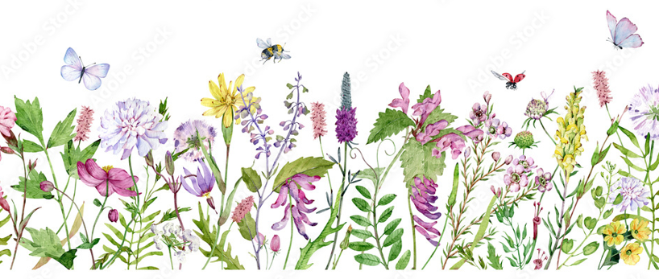
ALL PROCEEDS TO THE YORKSHIRE WILDLIFE TRUST

