Welbury Show Rules
- All classes are Open Classes to encourage participation.
- All entries in the Garden Produce and Garden Flowers categories must be the produce of the exhibitor’s own garden.
- Exhibitors may enter a maximum of two entries per Class.
- Please do not enter items entered in previous years.
- Each exhibitor must use a separate entry form.
- Fees must be paid when entries are made.
- Please submit entries to Joanne Hughes at Tile Shed Farm or put into Welbury village hall post box (white box to the right of the kitchen door around the left side of the building) before 6pm Thursday 7th August.
- Exhibits must be staged between 8.30am and 10am on the morning of the show.
- No responsibility will be accepted for any loss or damage to any exhibit or container.
- The Show Committee’s decision is final.

WELBURY SHOW TROPHIES

See Welbury Village Hall Notice board

Welbury Village Show
2pm Saturday 9th August 2025

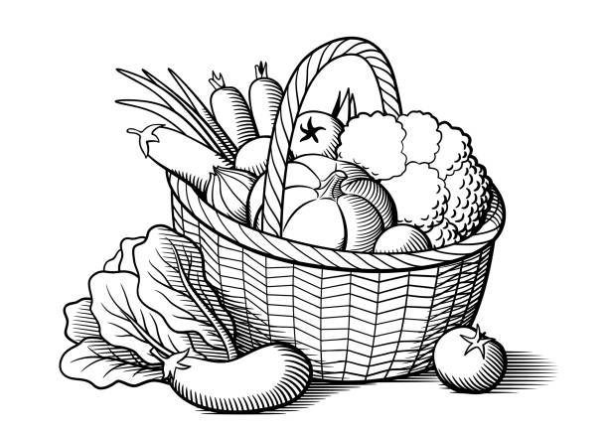

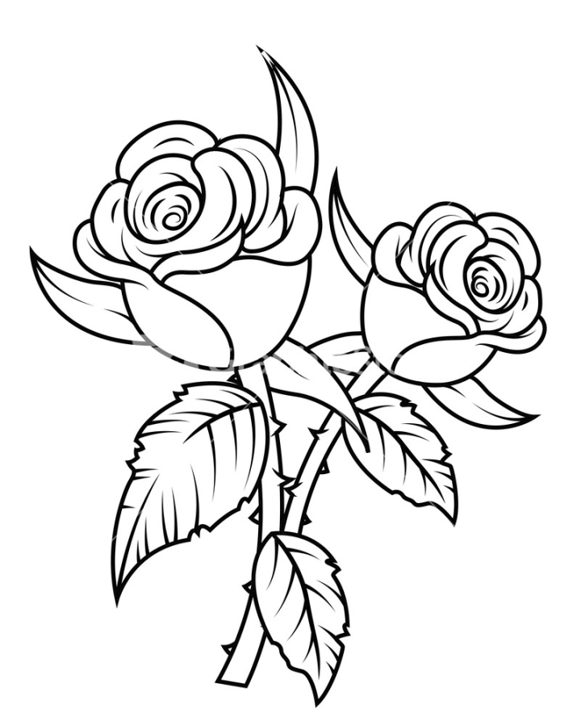

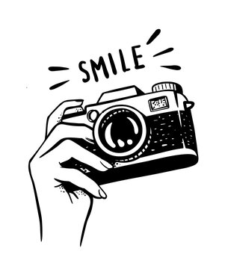
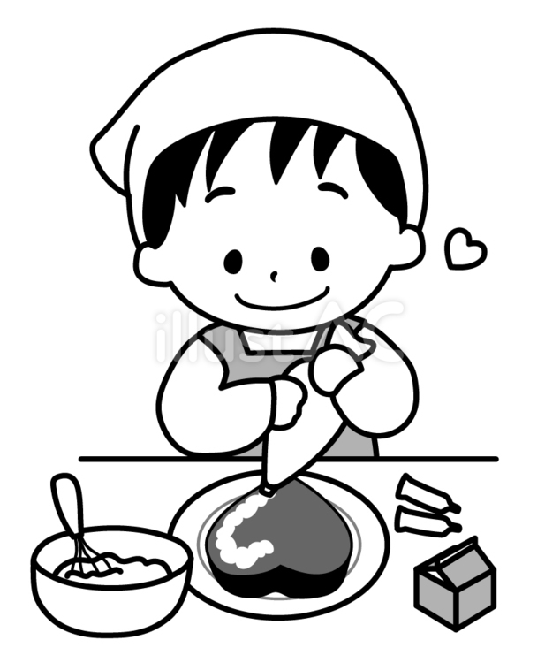

Garden Produce
1 3 Radish
2 3 Onions, undressed
3 2 Courgettes
4 3 Beetroot – with tops and roots complete
5 4 Potatoes
6 4 Sticks of rhubarb
7 The longest stick of rhubarb
8 4 Pods of beans, single variety
9 3 or more Tomatoes – with cylix attached
10 3 Plums (Any Variety)
11 3 Eggs ( one of which cracked onto a saucer)
12 Any other vegetable or fruit not covered by
classes 1-13
13 A bunch of fresh herbs

Garden Flowers
14 1 Perfect rose
15 3 Stems of perennials (all of 1 variety)
16 3 Stems of annuals (all of 1 variety)
17 3 Stems of sweet peas
18 3 Fuchsia florets any variety (flower only)
19 1 Stem of cut flowering shrub

Entry Form – all entries 25 pence
To be completed by the exhibitor, accompanied by the appropriate fee, and sent to Joanne Hughes by Thursday 7th August 2025. Please include the age of children if under 16.
Class Number | Class Title | No. of Entries | Total Fee | Age of child
Total Fee Enclosed |  | £
Print
Name
Address
Tel. No.
Signature

Children's Classes

Under 7 years
53 Something I have made
54 A painting or drawing any medium
55 3 Home-made fairy cakes
56 A decorated cress egghead
57 A decorated pebble

7-10 years
58 Something I have made
59 A painting or drawing any medium
60 A scene in a shoebox lid
61 Something made from home-made pompoms
62 A decorated cress egghead
63 3 Home-made fairy cakes
64 A decorated pebble
65 Written in your best handwriting
There was an old man with a beard,
Who said, “It is just as I feared!
Two owls and a hen,
Four larks and a wren,
Have all built their nests in my beard!

11-16 years
66 Something I have made
67 A painting or drawing any medium
68 A scene in a shoebox lid
69 Something made from home-made pompoms
70 A handmade bracelet
71 A photo I have taken with caption
72 Written in your best handwriting
There was an old man with a beard,
Who said, “It is just as I feared!
Two owls and a hen,
Four larks and a wren,
Have all built their nests in my beard!

All children's classes are open and there will be
a prize for every child entering

Design the front cover of the 2026 Village Show for an extra prize!

Indoor Plants
20 A pot plant (foliage)
21 A pot plant (flowering)
22 1 Cactus or succulent

Flower Arranging

23 A flower arrangement in an unusual container

24 A miniature flower arrangement (max 4” in any direction)

25 An arrangement of greenery & seed heads

Preserves
26 A jar of jam, any variety
27 A jar of marmalade, any variety
28 A jar of chutney, any variety
29 Fruits of the Hedgerow - alcoholic, 50ml or more
30 Fruits of the Hedgerow – non-alcoholic, 50ml or more

Home Baking
31 3 Muffins (not English muffins)
32 Tea loaf
33 3 Scones sweet or savoury
34 3 Jam tarts
35 Men only cake (any variety)
36 Victoria sponge with raspberry jam filling only
37 3 Ginger flavoured biscuits
38 3 Chocolate Brownies (plain or flavoured)
39 3 Fingers of Flapjack
40 Banana Bread
41 Cheese Sables using Linda Crosby’s recipe in the Welbury Diamond Jubilee Cookbook (copies of the Cookbook are on sale in Welbury church).

Photography maximum size 8”x6” all classes
42 A print, with CAPTION written on
paper 4"x1"
43 A print, subject “Seaside"
44 A print, subject "Sunset/Sunrise"
45 A print, subject “Close up"

Handicrafts

46 A handmade greetings card

47 A hand knitted or crocheted article
48 A painting using oil or acrylic paint
49 A watercolour painting
50 A drawing any medium
51 An item of embroidery or cross-stitching
52 Something I have made

